**Word Priming Experiment**

PSY 310: Lab in Psychology

5th November, 2024

Suhani Pandya

AU2220117

Github Link -

**Introduction**

A word priming experiment curtails of examining how exposure to one word that is the prime affects the response to another word that is the target. “*Priming*, or, the *priming effect*, occurs when an individual’s exposure to a certain stimulus influences their response to a subsequent prompt, without any awareness of the connection. These stimuli are often related to words or images that people see during their day-to-day lives.” (*Priming - the Decision Lab*, n.d.)

Implicit memory is the main working mechanism in this experiment, implicit memory is where information is recalled without conscious effort. For example, if the prime word is “dog” and the target word is “bone” there will be a faster association made by the participant than the prime word being “dog” and the target word being “tree”. This shows that the brain has unconsciously forms links between things that are related. Priming depicts the implicit cognition connections formed via language, experiences and culture. Such experimenters use these results to gain knowledge on different domains such as semantic memory, cognitive processing etc. Word priming experiments are important in studying language, memory and perception. These findings help infer about greater understanding of human cognition, retrieve information and how our perceptions are shaped by prior experiences.

**Method**

The experiment was conducted with 4 participants, with each of them participating in 30 trials of the experiment. Participant 1 was a 20-year-old, Life sciences major at Ahmedabad University, Participant 2 was a 19-year-old, Psychology major at Ahmedabad University, Participant 3 was a 19-year-old, from Karnavati university and Participant 4 was a 17-year-old, school going student. All the participants were given clear instruction and their consent was taken. Phase 1, which included showing the participants 15 Study_word (primed words) shown to participants ‘study’ words, which were acting as the prime. For this an excel sheet was created with the criteria of ‘study_words’ and words were added to it (Figure 1). There was also a slider added to understand how ‘familiar’ or ‘unfamiliar’ the participants were with the presented words (Figure 2). Phase 2 introduced new words (non-primed); this was also done by making a different excel sheet with all the words added including 5 new ones which were the non-primed words as well (Figure 3).The study words were presented on screen for 8 seconds (Phase 1) whereas the test words were presented for 10 seconds (Phase 2) where participants had to fill in the missing letters for words 15 primed and 5 non-primed words that would be shown on screen (Figure 4). Both trials had 1 loop that were randomised. The priming score was calculated by subtracting the proportion of ‘hits’ or accurate words identified by the participants for the non-primed words from the primed words.

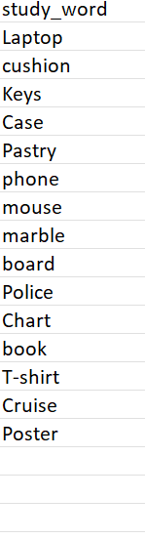Figure 1: - Primed words to show participants

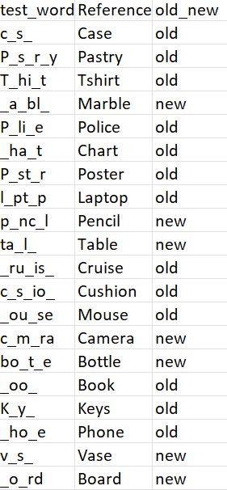

Figure 2-: List of Test and Study words as well as words with missing letters which are to be completed. by participants

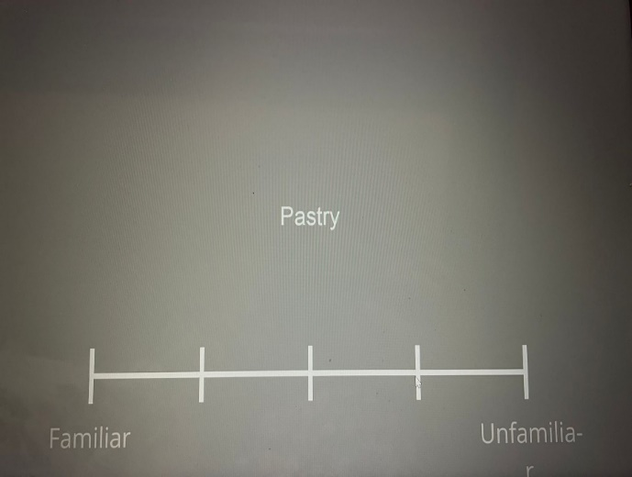

Figure 3: Phase 1, Word shown with a scale where participants can respond with how familiar or unfamiliar the word is to them

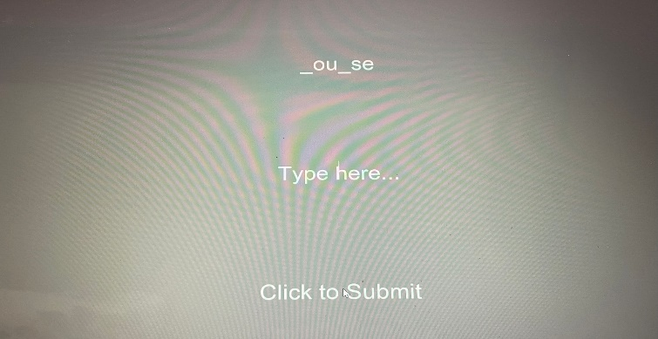 Figure 4: Phase 2, participants shown words with missing letters to fill in (primed and non-primed words mixed)

**Results**

**The priming scores of the 4 participants are: -**

Participant 1- 0.35 (prop of hit study words (0.65)- prop of hit non study words (0.3))

Participant 2- 0.3(prop of hit study words (0.65)- prop of hit non study words (0.35))

Participant 3- 0.35(prop of hit study words (0.6) – prop of hit non study words (0.25))

Participant 4- 0.35(prop of hit study words (0.6)- prop of hit non study words (0.25))

In all cases we see that proportion of study words is greater than that of non-study words because the participants retained the study words in their long term memory.

**Discussion**

Conducting experiments with large sample size and diverse one’s can lead to more generalisability of the results. Excluding the words with high familiarity by administrating a pretest on the participants to reduce bias. Experimenting with the exposure time of prime words to test the cognitive capabilities in relation to real word conditions and observe its long-term side effects. Designing experiments that curtail real life scenarios for better validity such as including naturalistic stimuli and tasks. Combination of reaction time with other measures such as word priming's effects on cognition and memory may also be better understood by employing sophisticated neuroimaging methods like fMRI or EEG, which may shed light on the brain mechanisms underpinning priming effects.

**References**

*Priming - The Decision Lab*. (n.d.). The Decision Lab. <https://thedecisionlab.com/biases/priming>

*Priming Words - YellowBox Careers*. (n.d.). YellowBox Careers. <https://yellowboxcareers.com.au/lessons/priming-words/>